Experiment 15: Cloning a Virtual Machine
Aim
To create a clone of an existing Virtual Machine and test it using VirtualBox.
Steps
- Power off the original VM.
- Right-click the VM → Select Clone.
- Choose clone name.
- Select Full Clone.
- Choose Current machine state.
- Complete the cloning process.
- Start the cloned VM.
- Verify OS and settings.
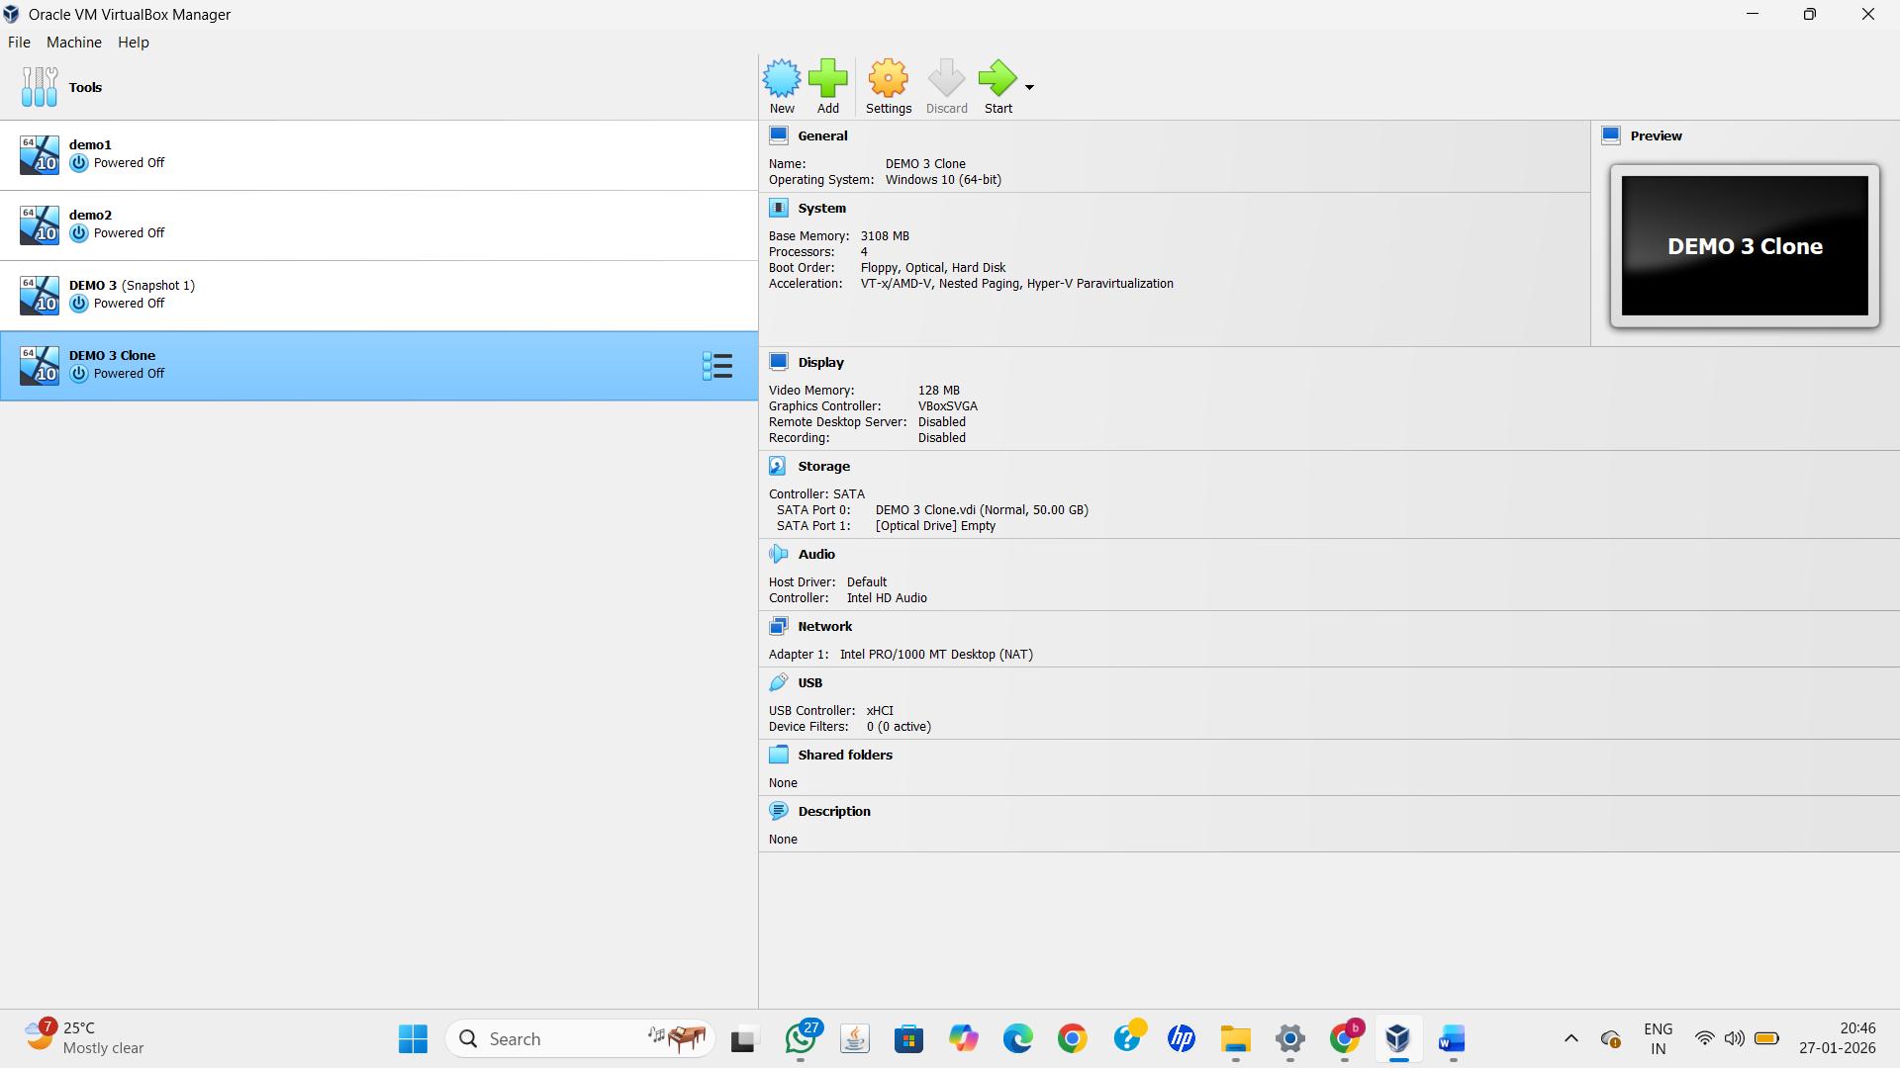
Result
A cloned Virtual Machine was successfully created and tested without affecting the original VM.

